Pioneer 1000 Install instructions
For Technical Support Call: (740)858-0707
- Place straps around bars like shown. One on each side, and two on front rollbar.
Note: There are two different size clamps use the ones that fit the best.
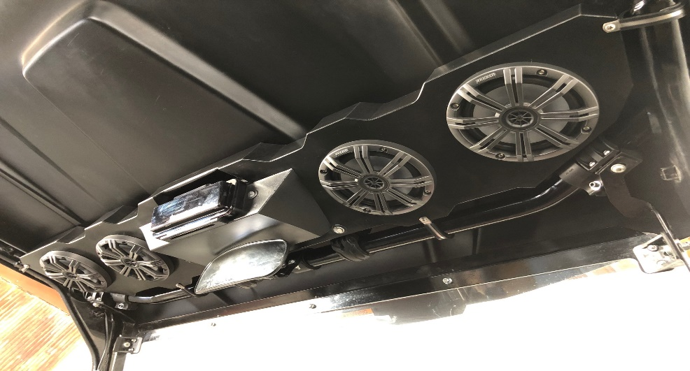
- Hold stereo box against the roof, all the way to the very front. (this is easier with someone to help)
- Screw clamps to box with self-drilling screws, DO NOT tighten until all clamps are installed with screws. SCREWS CAN STRIP OUT! Example below
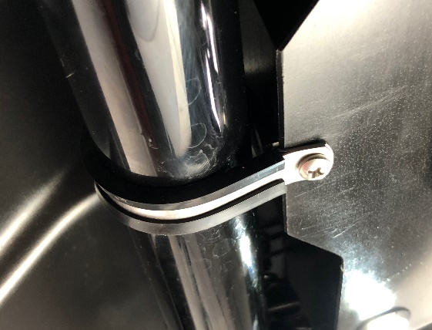
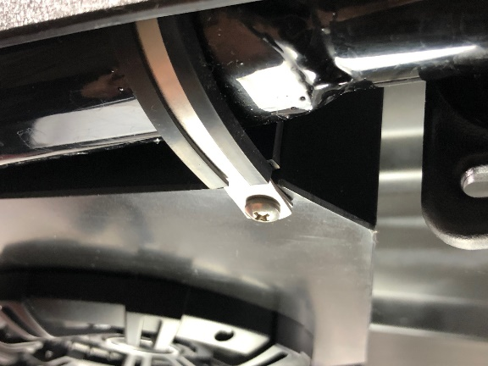

- Run wire across driver cage bar to battery. Keep wire on inside of cage, secure with zip ties.
- Make the battery connections (this has to be done last!).
IMPORTANT: The fuse goes to +12V red side! (see photo)
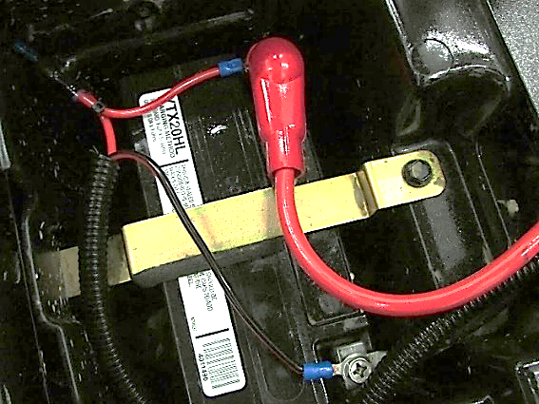
*IF CONNECTED BACKWARDS IT WILL BLOW FUSE IN HEAD UNIT!!!!!!
Sony Tuning
Band1: -3
Band2: -2
Band3: 0
Band4: 5
Band5: 9

.

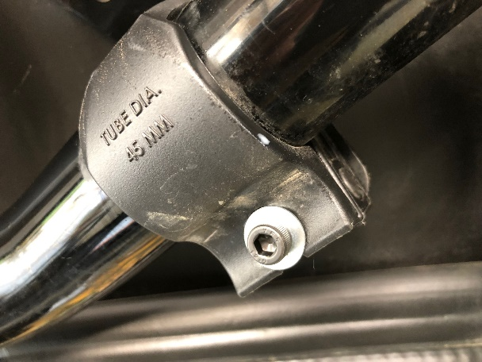
Note: The 2- M6-1.0 x 30mm socket head cap screws and the 2- ¼ “ Flat Washers are to remove the swing clamps to install the stereo, NOT all machines have these.

