Can am Defender Install Instructions
Customer Service: 740-858-0707
Supplied hardware:
- 2- L Brackets
- 2-1 ½” Stainless Screws
- 8-1” self drilling screws
- 2- Hex head bolts
- 4- Washers
- 2- Nylon lock nuts
- 10- Zip ties

Step One: Attach “L” bracket to left and right sides of the stereo box with the supplied screws.
Step Two: Attach box to cage using the other side of the “L” bracket with the supplied screws, once the “L” bracket is in the channel of the cage, push the stereo box all the way forward to the front of the cage.
Step Three: Drill holes through factory roof plate where you would like to mount the blots to hold the front of the stereo (We recommend that you take out a speaker to access where you put the nut).

Step Four: Drill corresponding holes in the stereo box for the two supplied bolts.

Step Five: Bolt stereo to factory roof plate using the supplied blots, nuts and washers.
Step Six: Run power and ground wires directly to battery securing with supplied zip ties.
****Hooking up stereo backwards will BLOW FUSE IN HEADUNIT !!!!
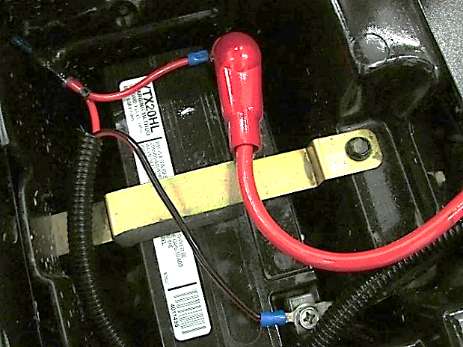
Step Seven: Power up and enjoy your stereo!

