Polaris General Installation Instructions
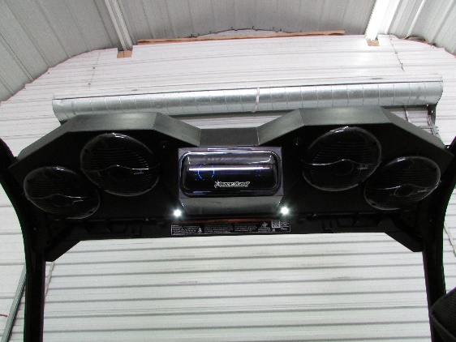

- Please make sure your box contains the following:
  - Overhead stereo unit for Polaris general (as pictured).
  - Installation kit.
    - 2- L Brackets
    - 2- 1 1 ½“ screws
    - 8- 1” self-drilling screws
    - 2- 1 ¾” Stainless steel clamps
    - Cable ties

- Things you will need:
  - Electric Screw gun (drill)
  - T40 Torx bit

Step One: Take your T40 torx and remove the four bolts holding on the factory visor. Set bolts and visor to the side.
Step Two: Remove visor.

Step Three: Obtain your 2 L brackets and your 6- 1” screws. Position L bracket on outside of Left and Right side of stereo and secure with 3 screws in the holes provided in the brackets. The L bracket can be placed in any position on side to clear any accessories. Make sure top of box extends past top case.
Step Four: Take stainless clamps and put around the straight bar of the cage that was under the visor (L foot of clamp towards the outside).
Step Five: You should now be able to set stereo in the cage by putting the foot of the L bracket into the factory channel of the roll cage.
Step Six: Adjust stereo to the very front most part of the roll cage (corner are tailored to cage)
Step Seven: Take your last 2- 1” Screws (self-drilling) and secure L brackets to the roll cage using appropriate hole in bracket.
Step Eight: Take your 2- 1 1/2” screws and run into the 2 clamps (adjusting to clear visor clamps) and directly into box.
Step Nine: Run loomed wire directly to the battery. Take wire and run towards the driver seat and down the back of the cage behind seat.
Step Ten: Secure red side of wire with the fuse holder to the positive post of the battery. Black wire to negative post.
Step Eleven: Reinstall seat and upper visor and enjoy!]

*NOTE* The first time you hook up your Swamp Donkey System you will have to make sure your power switch is on the ON position and then press the power button on the head unit. Once this is done you can use the master switch to turn radio on and off.

